# Apply filters to SQL queries

## Project description

The use of SQL as a cyber security analyst is a great tool. The use of ‘where’ and search for employees information or office position and the use of ‘OR’ also ‘NOT’ to navigate my search. Some key words used to filter search results ‘LIKE’ and more also how to use date and time, search for countries and many more.

## Retrieve after hours failed login attempts

[Add content here.] The retrieval of failed login attempts after hours can be done using the filter code 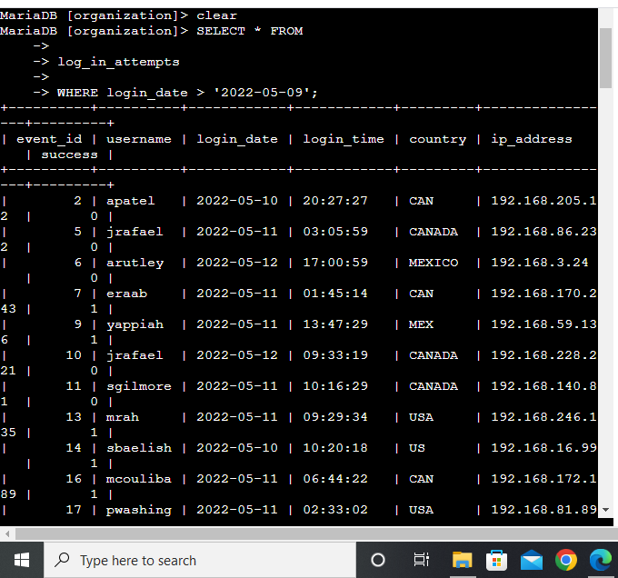

## Retrieve login attempts on specific dates

Retrieving attempts can be done using filters example date and time, >=, < and so other filters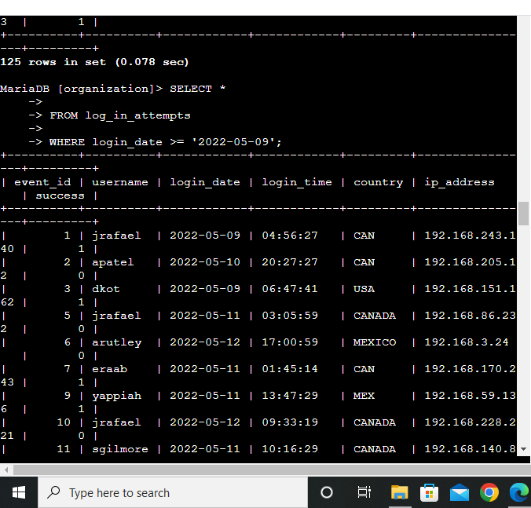

## 

## 

## 

## Retrieve login attempts outside of Mexico

Using the operator ‘NOT’ before the ’ WHERE’ example on image below

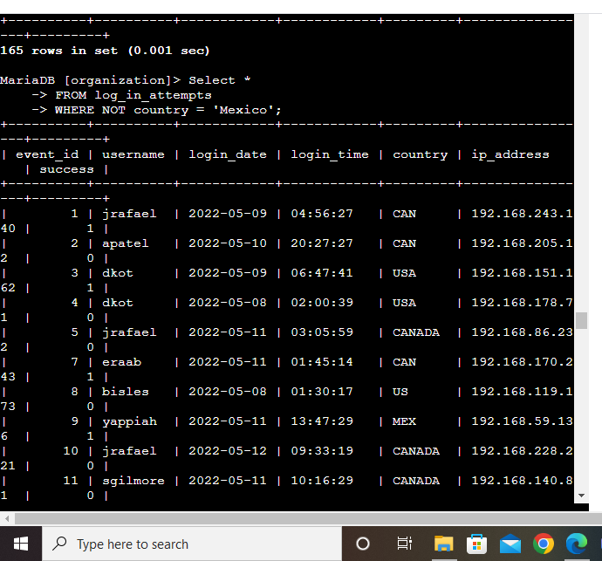

## Retrieve employees in Marketing

USING

Select *

FROM employees

WHERE department = ‘Marketing’;

run.

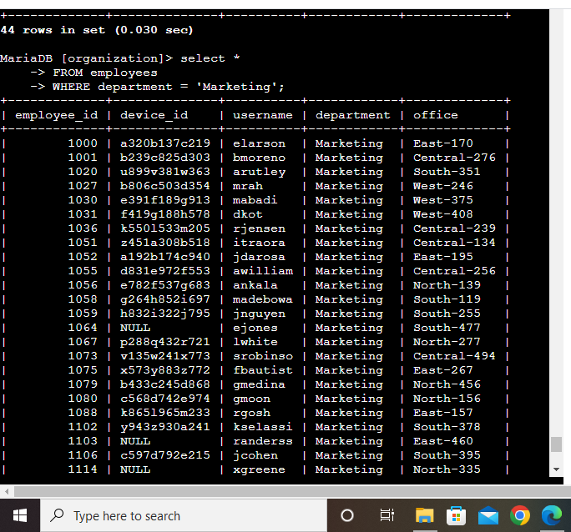

## 

## Retrieve employees in Finance or Sales

USING

Select *

FROM employees

WHERE department = ‘Finance’ OR department = ‘Sales’;

Run.

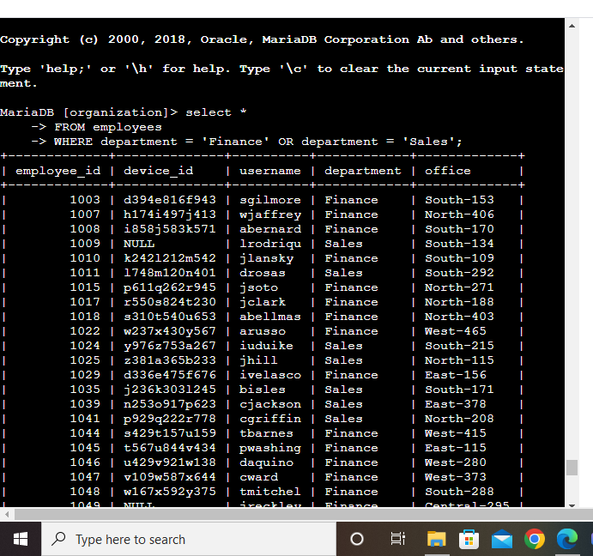

## Retrieve all employees not in IT

USING

Select *

FROM employees

WHERE NOT department = ‘information technology’;

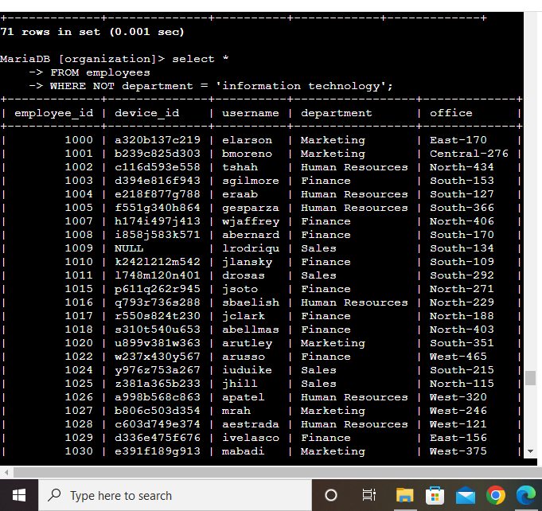

## Summary

The SQL database is a very useful tool as a cyber security analyst and the use of filters amd operators and syntax and more of the SQL tool is a great add to becoming a very good cyber security expert and help mitigate risk and monitor the activities within the organizations network and internet security.